# Section 1: The Birth of the Buddha Gotama

The appearance of a Buddha in this world is an event of immeasurable significance—a rare and wondrous occurrence that illuminates the path to liberation for countless beings. A Buddha does not arise by chance but through the boundless perfections (pāramī) cultivated over countless lifetimes. His birth marks the culmination of an extraordinary journey, a moment when wisdom, compassion, and virtue manifest in their highest form for the welfare of all.

In this section, we reflect upon the profound significance of the birth of the Bodhisatta, who would one day become the Supreme Teacher of gods and humans, the Buddha Gotama. While the Tipiṭaka does not specify the exact year of his birth, the ancient traditions of Southeast Asia widely accept that he was born in 623 B.C. on the full moon day of May (Vesākha or Vesak)—a day that remains sacred to millions who honour his life and teachings. ).[1]

Emerging into this world in the sacred grove of Lumbini, he took his first steps upon the earth, symbolizing the arrival of one who would walk the path of truth and guide others beyond suffering. From that blessed moment, his life unfolded as a beacon of wisdom, illuminating the northern lands of ancient India—then known as Majjhimadesa (the Middle Country)—where he would fulfill his great mission of awakening.[2]

The birth of a Buddha is not merely a historical event; it is a rare gift to the world, a cause for boundless rejoicing, for such a being arises solely out of infinite compassion to reveal the Dhamma—the way to the highest peace, Nibbāna.

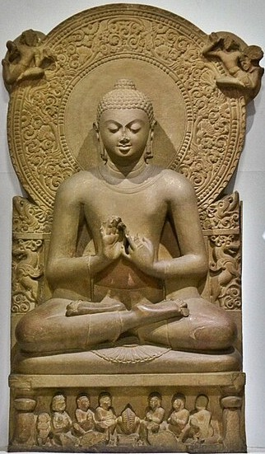

**Buddha in Sarnath Museum (Dhammajak Mutra) [3]**

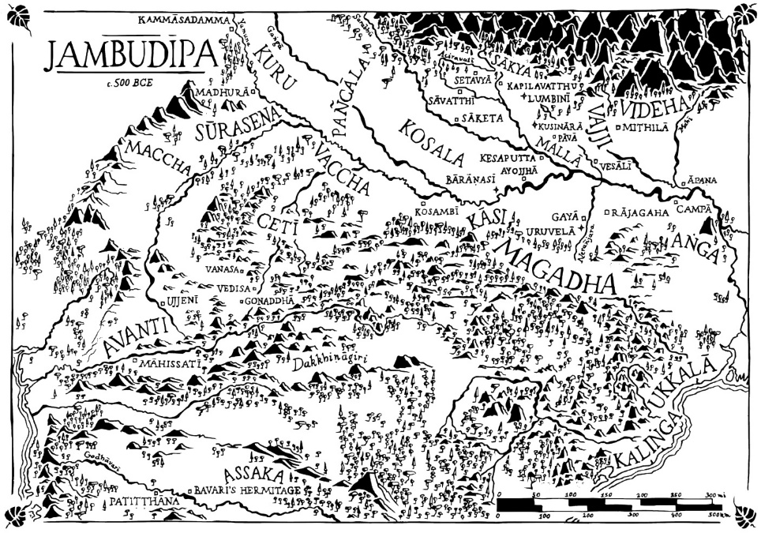

**Map showing the Jambudȋpa during the time of Gotama Buddha [4]**

## The Profound Significance of the Buddha’s Birth

The birth of the Buddha is an event of unparalleled significance—an extraordinary moment in the vast unfolding of time. The appearance of a Buddha in the human realm is a rare and wondrous occurrence, for he is an awakened being, a supreme teacher who illuminates the path from suffering and discontent to the ultimate freedom of Nibbāna. His wisdom is a guiding light, his compassion boundless, and his teachings an enduring refuge for all who seek liberation.

The scriptures speak of the immeasurable impact of such a being:

*“…There is one person who arises in the world for the welfare of many, for the happiness of many, out of compassion for the world, for the good, welfare, and happiness of devas and human beings… Who is that one person? The Tathāgata, the Arahant, the Perfectly Enlightened One…”[5]*

The coming of a Buddha is not an ordinary occurrence; it is the arising of a supreme physician who heals the afflictions of the world, a peerless guide who leads beings across the ocean of suffering. He does not merely teach the Dhamma—he embodies it. With infinite patience, he reveals the path for those who wish to walk it, awakening countless beings to the truth.

The birth of such a being is not just significant—it is a cause for deep reverence and gratitude, for with him comes the opening of the door to the highest peace, the deathless, the unshakable liberation of Nibbāna.

**Why is the Birth of the Buddha So Profoundly Significant?**

The birth of a Buddha is one of the rarest and most transformative events in the human realm. It is a moment of immense significance, for it heralds the arrival of an enlightened being—one who has transcended all ignorance and suffering, who embodies boundless wisdom and compassion, and who dedicates his life to leading countless beings toward liberation.

The Dhamma—the sublime teachings revealed by the Buddha—is an incomparable gift to the world, providing a guiding light for those seeking to transcend suffering and attain true peace. Without the appearance of a Buddha, the path to enlightenment remains hidden, lost to the world. It is only through the supreme realization of such an awakened being that the forgotten path is rediscovered, explained, and made accessible to all.

In the cycle of birth and death, where beings wander endlessly through suffering, the emergence of a Buddha is an event of supreme rarity and immeasurable value. He is the one who, out of deep compassion, offers a way out of this endless cycle—a way to Nibbāna, the ultimate liberation. The Buddha’s birth is not merely a historical occurrence; it is a cause for rejoicing among both devas and humans, for it signifies the opening of the doors to the Deathless.

The scriptures express this truth with great reverence:

“… There is one person who arises in the world  
for the welfare of many people,  
for the happiness of many people,  
out of compassion for the world,  
for the good, welfare, and happiness  
of devas and human beings …  
Who is that one person?  
The Tathāgata, the Arahant,  
the Perfectly Enlightened One…”

The birth of such a being is beyond measure in its significance. It is an event that reshapes the course of human history, bringing forth a timeless teaching that continues to inspire and guide beings even today. The Dhamma, proclaimed by the Buddha out of pure compassion, remains a beacon of wisdom, offering all who seek it a path toward freedom, peace, and the highest happiness.

Thus, when a Buddha is born, the world is blessed beyond words. The great darkness of delusion is dispelled, and the radiant light of truth shines forth once more, illuminating the way to the highest goal—Nibbāna.

**The Buddha descending to this world**

“…and on Lord Buddha, waiting in that sky,

Came for our sakes the five sure signs of birth

So that the Devas knew the signs, and spoke

” Buddha will go again to help the World.”

” Yea!” spoke He, “now I go to help the World

This last of many times; for birth and death

End hence for me and those who learn my Law.

I will go down among the Sākyas,

Under the southward snows of Himalay,

Where pious people live and a just King.” [6]

## The Bodhisatta Descends from the Tuṣita Deva Realm

According to Buddhist scriptures, the Buddha was born in a human realm as a Bodhisatta [7], having spent a period of time in the “deva” realm of Tuṣita’ [8].

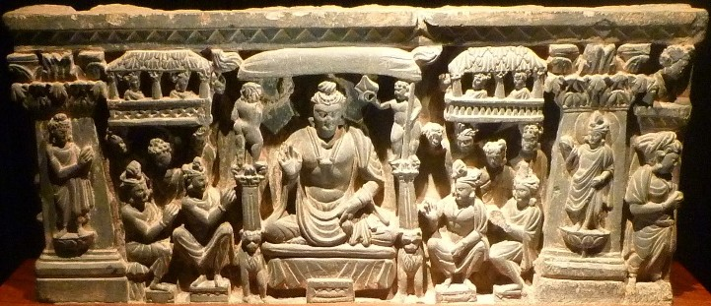

**Bodhisatta in Tuṣita Heaven [9]**

**Venerable Ānanda** [10] is quoted in the suttas, describing the birth of the Buddha:

*“…I heard and learned this, Venerable Sir, from the Blessed One’s own lips: ‘Mindful and fully aware…the Bodhisatta appeared in the Tusita heaven …the Bodhisatta remained in the Tusita heaven …the Bodhisatta passed away from the Tusita heaven” and descended into his mother’s womb”* [11]

## The Bodhisatta’s Birth into a Royal Family

The Bodhisatta was born into the noble Sakyan dynasty, a lineage of warrior-kings known for their wisdom and strength. His parents, King Suddhodana and Queen Mahāmāyā, ruled from the royal capital of Kapilavatthu, a prosperous city in the Sakyan province.

According to ancient Buddhist tradition, the moment the Bodhisatta descended into Queen Mahāmāyā’s womb was marked by a remarkable vision. That night, the queen experienced a dream of profound significance—one that foretold the arrival of an extraordinary being who would change the course of history.

### Queen Mahāmāyā’s Dream

On a radiant full-moon night, as Queen Mahāmāyā lay asleep in the palace, she had a vivid and wondrous dream. She felt herself being gently lifted by four celestial beings and carried to Lake Anotatta, a sacred and pristine lake nestled in the Himalayas. There, the devas bathed her in the pure waters, adorned her in divine garments, anointed her with fragrant perfumes, and decorated her with heavenly flowers.

As she rested in this sublime state, a magnificent white elephant appeared before her, holding a pure white lotus in its trunk. With grace and majesty, the elephant circled her three times before entering her womb through her right side. [12]

This sacred vision was a divine omen, signifying that the child she carried was no ordinary being. It heralded the birth of a great being, an amazing gift to the world!

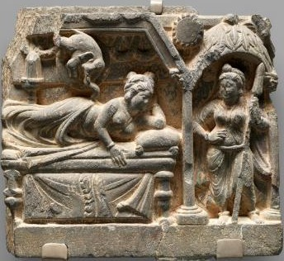

**Dream of Mayadevi [13]**

## The Birth of the Bodhisatta at Lumbini Park

According to ancient tradition, Queen Mahāmāyā, the wife of King Suddhodana, set out from the royal city of Kapilavattu to travel to her parental home in Devadaha, as was the custom for expectant mothers of noble lineage. Along the journey, she came upon the enchanting Lumbini Park, a serene grove where Sāl trees stood in full bloom, their delicate flowers filling the air with a sweet fragrance.

Captivated by the beauty of the place, the queen entered the park with her attendants. After bathing in a clear pond, she strolled through the grove, admiring its peaceful splendour. As she reached for a branch laden with blossoms, holding it gently in her hand, a wondrous moment unfolded—the Bodhisatta was born.[14]

## The Miraculous Signs at the Birth of the Bodhisatta

The birth of a Bodhisatta is unlike any other—it is a moment of extraordinary significance, marked by divine signs that proclaim the arrival of a being destined to bring unparalleled wisdom and compassion to the world. The scriptures record that the birth of the future Buddha was accompanied by wondrous events, as vividly described by Venerable Ānanda: [15]

### A Child of Great Power

I heard and learned this from the Blessed One’s own lips:  
‘While other mothers give birth seated or lying down, the Bodhisatta’s mother did not. She gave birth standing, and the moment the Bodhisatta emerged from her womb, he did not touch the earth. Instead, four young devas received him in their arms and set him before his mother, proclaiming:

*“Rejoice, O Queen, a son of great power has been born to you!”*

At that very moment, an immeasurable light—surpassing even the radiance of the celestial realms—illuminated the entire world. [16]

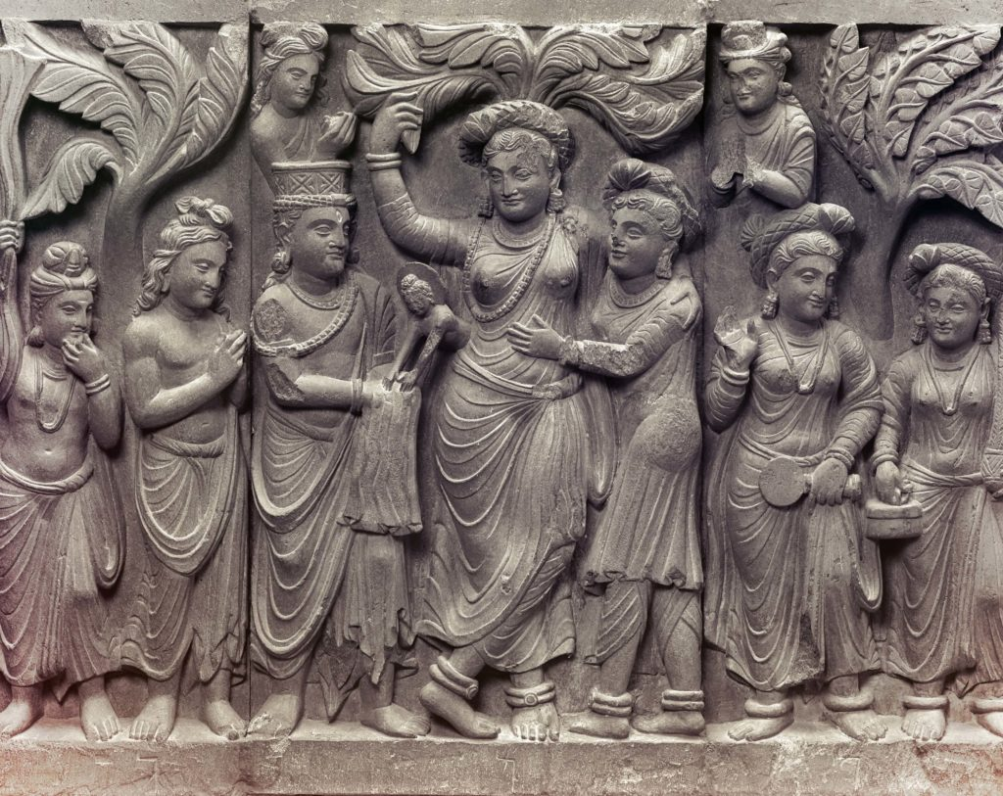

**Birth of the Buddha [17]**

### The Lion’s Utterance at Birth

The scriptures further recount that as soon as the Bodhisatta was born, he stood firmly upon the earth, took seven steps toward the north [18] , and gazed across the four quarters. A divine white parasol was held above him, signifying his noble destiny. Then, with a voice filled with wisdom and certainty, he made a profound declaration—his first utterance in this world:

*“I am the highest in the world;*

*I am the best in the world;  
I am the foremost in the world;*

*This is my last birth; now there is no renewal of being for me.”* [19]

These miraculous events were not mere wonders; they were signs of the Bodhisatta’s unique and supreme nature. His birth was not just the arrival of another being into the cycle of existence—it was the beginning of a glorious journey that would one day lead to his perfect enlightenment, the turning of the Wheel of Dhamma, and the liberation of countless beings.

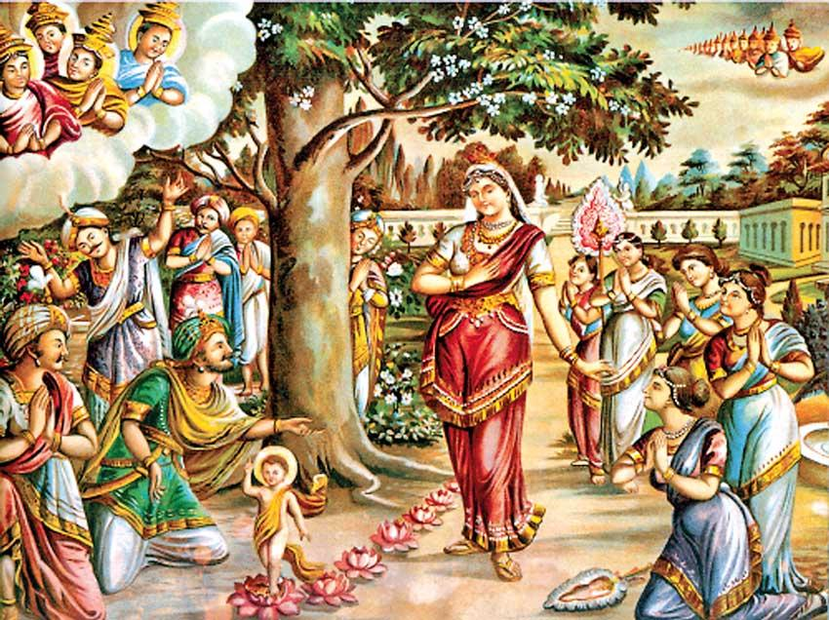

**The Bodhisatta taking seven steps** [20]

### The Birth of Bodhisatta is glorified in the following poem of Aśvaghoṣa

“ In that glorious grove, perceiving that it was time for the birth,

The queen took to a bed covered over with an awning,

being joyfully received into the bosom of thousands of fellow women.

Then, as a propitious moon passed into the asterism of Puṣya,

to that queen sanctified by the manner of her action –

Through her, for the welfare of the world –

a son was born, painlessly and healthily.

With brightness he shone, and with constancy,

like a newly-risen sun inundating the earth;

Thus, he blazed too brightly to be gazed upon,

and at the same time, he stole the eyes,

in the manner of the hare-marked moon.

For with the blazing light of his body,

he blotted out the light of lamps as does the sun;

And with his beautiful lustre of precious gold,

he enlightened all directions.

With even footsteps, his feet rising up like water-born lotuses,

and coming down in long stamping strides:

Seven such firm steps he took, looking like the Seven Seer cluster of stars” **[21]**

## The Devas Rejoice at the Birth of the Bodhisatta

According to the scriptures, the birth of the Bodhisatta was not only a moment of great significance for the human realm but also an occasion of immense joy in the celestial worlds. Sakka, the King of the Devas, along with his retinue, rejoiced and celebrated this extraordinary event. [22]

The great seer Asita, [23] witnessing the radiant festivities of the devas, was moved by curiosity and inquired about the reason for their boundless joy. In response, the devas proclaimed:

“*A being intent on awakening—an incomparable jewel—has been born in the human realm for the welfare and happiness of all. In Lumbinī, a village in the Sakyan land, this peerless one has arisen. That is why we rejoice, why our hearts are filled with bliss.*

*He is supreme among all beings, the foremost among men,- the chief of the world, the highest among all creatures. He will set the Wheel of Dhamma in motion, roaring like a mighty lion, the king of beasts.”[24]*

Such was the immense significance of the Bodhisatta’s birth—not only did it bring hope and joy to the human realm, but even the celestial beings recognized the arrival of a Supreme Teacher, one who would illuminate the world with the light of wisdom and compassion.

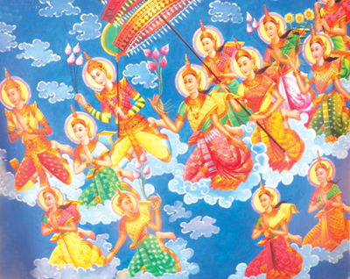

**Sakka the king of devas and his retinue rejoicing the birth of the Bodhisatta** [25]

## Lumbini Park: The Sacred Birthplace of the Gotama Buddha

The name Lumbini carries a meaning as beautiful as its significance— “lovely” in the Nepalese language. Both tradition and the sacred scriptures affirm that Lumbini, the hallowed site of the Buddha’s birth, was located within the Sakyan Kingdom of northern India, an area known in ancient times as the Middle Country (Majjhimadesa).

As we have seen in the verse sung by the rejoicing devas, they proclaimed the blessed event of the Buddha’s birth with these words: [26]

“*A being intent on awakening—an incomparable jewel—  
has been born in the human realm for the welfare and happiness of all,  
in* ***Lumbinī, a village in the Sakyan land****.”*

The Buddha himself later affirmed his noble origins in a conversation with King Bimbisāra of Magadha, as recorded in the Pabbajjā Sutta of the *Sutta Nipāta*. When the king inquired about his birthplace, the ascetic Siddhattha replied with these poetic verses:

*“To the north, O King, on the slopes of the Himalayas,  
lies a land rich in prosperity and strength.  
Its people dwell among the Kosalans,  
their noble lineage tracing back to the Sun.  
They are Sakyans by birth,  
and I have gone forth from that family.”* [27]

Thus, Lumbini was not just the geographical birthplace of the Buddha; it was the starting point of a journey that would transform the world—a journey that would lead to the enlightenment of one who would become the Supremely Awakened One, guiding countless beings toward liberation.

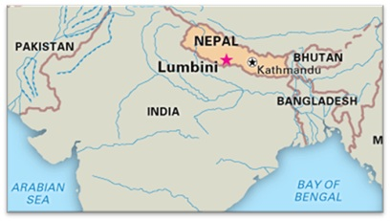

**Modern Map of India**

The modern map of India shows that Lumbini is located in Nepal, near the border with India. During the time of the Buddha, the entire Indian subcontinent, which included present-day Nepal, was referred to as Jambudīpa. According to Buddhist scriptures, the Buddha’s birthplace was in Kapilavattu, the royal capital of the Sakyan people. Therefore, Lumbini is traditionally believed to have been situated near this royal city.

Earlier, we encountered the words of Ascetic Siddhārtha, who, in speaking to King Bimbisāra, described his origins as coming from the Sakyan kingdom, located on the slopes of the Himalayan Mountain range. [28]Referring to the map below, we can observe that Kapilavattu lies just south of the Himalayan range.

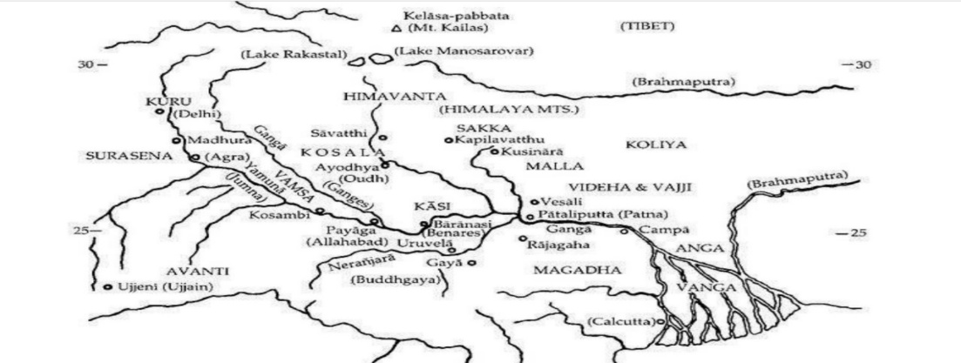

**Map showing the main provinces of North India during the time of the Buddha [29]**

## Evidence from Historical Sources: Lumbini as the Birthplace of the Buddha

The Asoka Pillar [30]

Historical and archaeological evidence confirms the significance of Lumbini as the Buddha's birthplace, with one of the most important findings being the Asoka Pillar. This ancient monument, erected by Emperor Asoka, is a key piece of evidence. [31]

Emperor Asoka, a devout follower of the Buddha, undertook a pilgrimage around 248 B.C. (3rd century) to visit significant Buddhist sites. During his visit to Lumbini Park, he had the pillar constructed as a mark of reverence and to honour the place of the Buddha's birth.

The discovery of the Asoka Pillar in 1896 was a monumental event, confirming Lumbini’s place in history as the Buddha's birthplace. The Mahāparinibbāna Sutta (DN:16) mentions the Buddha's birth as one of the four sacred sites for Buddhists to visit and reflect upon the greatest qualities of the Blessed One. [32]

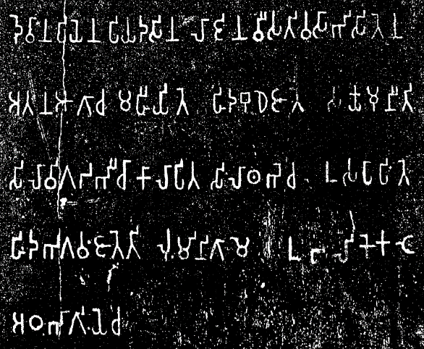

**Inscriptions on the Asoka Piller [33]**

**The Translation:** *Devānaṃpiyena Piyadasina lājina vīsati-vasābhisitena- atana āgāca mahīyite hida Budhe jāte Sakyamuni ti- silā vigaḍabhī cā kālāpita silā-thabhe ca usapāpite-* ***hida Bhagavaṃ jāte ti Luṃmini-gāme*** *ubalike kaṭe aṭha-bhāgiye ca.*

“When King Devanampriya Priyadarsin had been anointed twenty years, he came himself and worshipped (this spot) because the [Buddha Shakyamuni](https://en.wikipedia.org/wiki/Buddha_Shakyamuni) was born here. (He) both caused to be made a stone bearing a horse and caused a stone pillar to be set up, (in order to show) that the Blessed One was born here. (He) made the village of [Lummini](https://en.wikipedia.org/wiki/Lumbini) free of taxes, and paying (only) an eighth share (of the produce)”

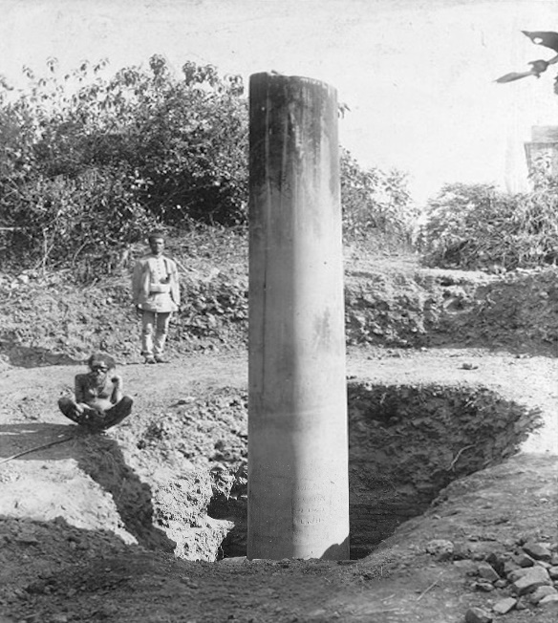

**Excavation of Asoka’s Piller in Lumbini [34]**

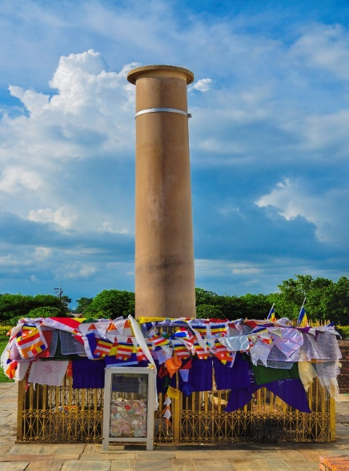

**Modern day Lumbini Piller[35]**

### Traveling Monks from China Visiting India

Another significant body of evidence supporting Lumbini as the birthplace of the Buddha comes from the accounts of two renowned Chinese monks: Faxian in the 5th century and Xuanzang in the 7th century. Both monks embarked on long pilgrimages from China to India, visiting ancient Buddhist sites along the way.

These two distinguished travellers from the Far East not only visited Lumbini, but also many other important Buddhist locations. Their detailed travel records, documenting their experiences, later became invaluable to archaeologists and scholars in identifying the Buddha’s birthplace, as well as other key Buddhist sites. [36]

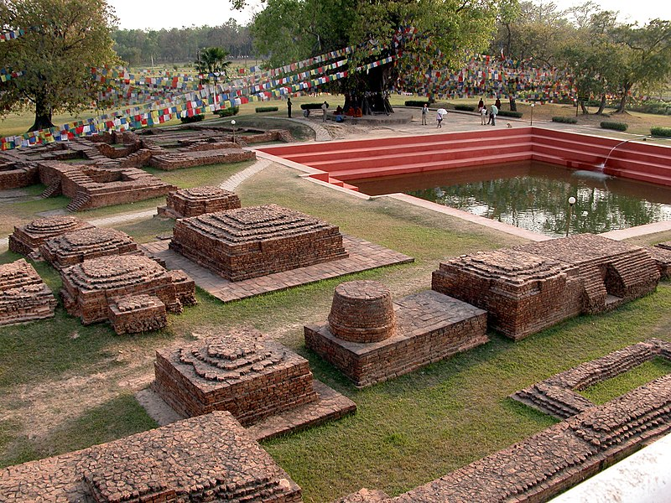

**Ancient ruins at Lumbini, Nepal [37]**

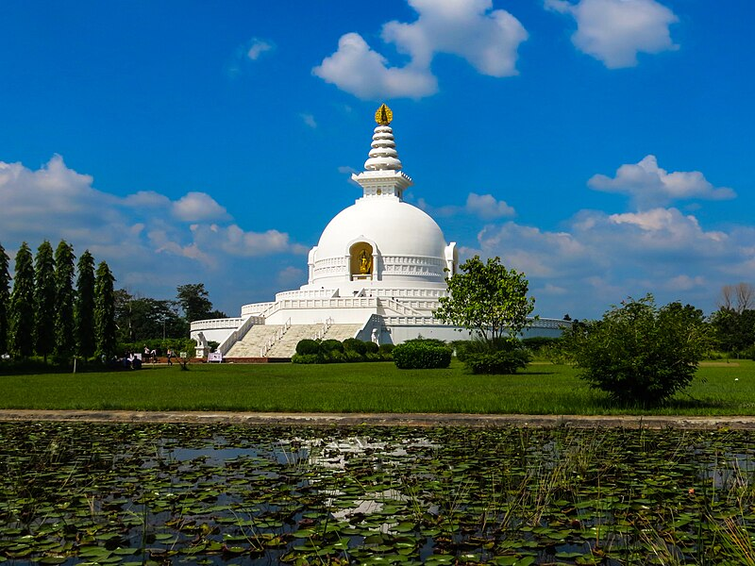

**World Peace Pagoda in Lumbini [38]**

## The Buddha: A Noble Sage of the Sakyan Clan

Throughout the scriptures, the Buddha is revered as a member of the noble Sakyan clan, which is why he came to be known as ‘Sakya Muni’, the sage of the Sakyans, and his disciples as ‘Sakya Putta’, the sons of the Sakyans. The Sakyan Republic was located on the edge of the majestic Himalayas, with Kapilavattu serving as their royal capital. Though the Sakyan Republic was under the rule of the King of Kosala, it was a republican state, where power was shared among its leaders.

According to both tradition and the scriptures, King Okkāka was regarded as the legendary ancestor of the Sakyans. The Ambaṭṭha Sutta (DN:3) recounts a passage that highlights the origins of the Sakyan clan in these words:

The Buddha said:

*“The Sakyans regard King Okkāka as their revered ancestor. Once, King Okkāka, who cherished his beloved queen, wished to transfer the kingdom to her son. To do so, he exiled his elder brothers, who took residence at the foothills of the Himalayas, beside a lotus-pond and a grand grove of teak trees”*

When King Okkāka inquired about his sons' whereabouts, his ministers informed him of their location. Upon hearing this, the king declared:

***‘****They are strong as teak (sāka), these princes, they are true Sakyans!’ And it is from this strength and resilience, like the teak tree, that the Sakyans derived their name. King Okkāka was their forefather, and from him, the noble line of the Sakyans continues.”*

Thus, the Buddha’s lineage is not only one of noble birth but also one of profound wisdom and strength, rooted in the strength of the teak trees and the enduring legacy of his ancestors. The Sakyan clan was marked by qualities of resilience and nobility, and it was from this noble lineage that the Sakyamuni arose, destined to awaken and share the path to liberation with all beings.

The Sakyans (also called Khattiya) were rulers, and they were known for their proud and noble nature. During the time of the Buddha, society was divided into four main classes: Brahmins, who served as priests and scholars; Kshatriyas, who were warriors, kings, and rulers; Vaishyas, who were merchants and traders; and Shudras, who were labourers and servants. The Sakyans, as part of the Kshatriya class, were regarded with a sense of pride and strength. Some of the attributes of the Khattiya class are expressed in the following verses:

“*The Khattiya is the highest among people,*

*for those who measure by lineage and honour...”* [39]

“*The aim of the Khattiyas is wisdom;*

*their foundation is power. Their ambition is for territory,*

*and their ultimate goal is sovereignty*.” [40]

Thus, the Sakyans embodied the qualities of leadership, ambition, and a deep pursuit of wisdom, standing proudly as rulers of their land and people.

## Kapilavattu the Royal City of the Sakyan

Tradition holds that the city of Kapilavattu was named in honor of the great sage Kapila. According to the legend, when the exiled princes of King Okkāka ventured into the Himalayan range in search of a place to settle, they came upon the hermitage of Sage Kapila, who welcomed them with kindness and offered them refuge. Grateful for his assistance, the princes later established a city and named it Kapilavattu as a tribute to the sage who had helped them.

In the Mahāpadāna Sutta (DN:14), there is a passage where the devas refer to Kapilavattu as the birthplace of the Buddha:

*“…In this fortunate aeon, the Lord Buddha has arisen in the world… His father is King Suddhodana, his mother was Queen Maya, and his royal capital is Kapilavattu…”*

Further, in the Mahāparinibbāna Sutta (DN:16), when the Buddha passed away, the Sakyans of Kapilavattu sent a request for his relics, as they considered themselves the rightful heirs of the Buddha’s legacy:

*“…The Sakyas of Kapilavattu heard of the Buddha’s passing, and they sent a message saying: ‘The Lord was the chief of our clan. We are worthy to receive a share of his remains, and we will construct a great stupa in his honor…’ The Sakyans of Kapilavattu built a stupa at Kapilavattu.”*

### Location of Kapilavattu

The map below shows the modern locations of Kapilavattu 1) site is in present day Nepal in Tilaurakot and the 2) site in Piprahawa of India.

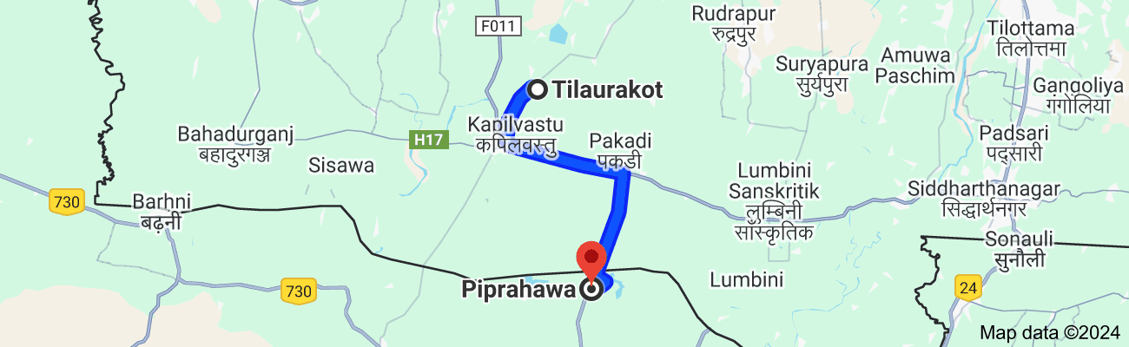

**Two locations of Kapilavattu: Tilaurakot, Nepal and Piprahawa, India [41]**

During the Buddha's lifetime, Kapilavattu was a prominent and well-known city located in the northern region of Jambudvīpa, the ancient name for the Indian subcontinent. As the capital of the Sakyan clan, it was a bustling, prosperous city with a rich cultural and political significance. Mahānāma, a prominent member of the Sakyan clan, described the city’s vibrant nature in this way:

*“This Kapilavattu is rich and prosperous, populous and crowded, with its thoroughfares congested. In the evening, when I return to Kapilavattu after visiting the Blessed One or the esteemed bhikkhus, I often encounter stray elephants, horses, chariots, carts, and even people wandering about in excitement…”*[42]

This passage paints a vivid picture of the city’s lively, bustling atmosphere, filled with activity and spiritual significance.

According to tradition and scriptures, Kapilavattu eventually met its destruction at the hands of King Vidudabha, the son of the late King Pasenadi Kosala. This tragic event marked the end of an era for the city, but Kapilavattu's importance as the birthplace of the Buddha and the home of the Sakyan clan continues to resonate throughout Buddhist history. [43] .

The ruins of Kapilavattu, the Buddha’s birthplace, were discovered relatively recently during the period of British India (1858-1947). Archaeologists identified two potential sites near the Nepal-India border: one in Nepal and the other in India. The site in Nepal, known as Tilaurakot, is located in the present-day Kapilavattu District, while the site in India, known as Piprahwa, is a village near Siddharthnagar in the state of Uttar Pradesh.

The debate over the exact location of Kapilavattu remains unresolved. However, the two sites are relatively close to each other, situated just 27 kilometers apart, and both lie near Lumbini, the birthplace of Prince Siddhartha. [44]

Below are the pictures of the two sites:

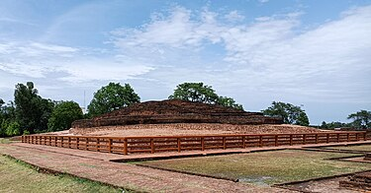

**Stupa at Piprahwa village in Uttar Pradesh, India** [45]

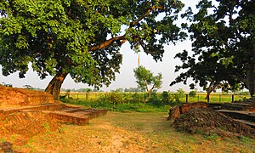

T**he east gate at the Tilaurakot archaeological site in Nepal [46]**

### Summary

In this section, we have briefly outlined the birth of Gotama Buddha and the significant events that occurred during that time:

* Buddha Gotama was born in 623 B.C. as a prince in Lumbini Park, located in the Sakyan province. His parents were King Suddhodana and Queen Mahamaya from the royal capital of Kapilavattu.
* The appearance of the Buddha in the world is a unique event because he rediscovered the lost path to liberation and generously shared his knowledge and experiences with others, benefiting countless beings through his teachings.
* According to the scriptures, Lumbini is one of the four sacred places for Buddhist pilgrims, as recommended by the Blessed One in the Mahāparinibbāna Sutta (DN:16). Visiting the birthplace of the Buddha helps strengthen the faith of devotees and inspires a sense of urgency in the pursuit of liberation from samsāra. It serves as a reminder of how the Blessed One urged his followers to be diligent and hasten toward enlightenment.
* Archaeological and historical evidence confirms that the birth of Buddha Gotama took place at Lumbini.
* Based on archaeological findings, two potential sites have been identified as the royal capital of Kapilavattu. While the exact location remains unresolved, most modern-day pilgrims visit both sites as part of their sacred journey.

This isthe end of this section; in the Next section (2) we will focus on Prince Siddhartha and his family.

### Endnotes: Section 1

1. Unlike the Christian Era, the Buddha Era is reckoned from the death of the Buddha, which occurred in 543 BCE (in his 80th year), and not from his birth. * See: Buddha and his teachings by Venerable Narada Mahathera, p. 3. * For details regarding **‘Middle country’** see: section 14.
2. See: Section 13, which gives detail account of majjimadesa.
3. Source: <https://en.wikipedia.org/wiki/The_Buddha>
4. Source: Suttacentral: <https://suttacentral.net/>
5. Source:AN1:170.* **Tathāgata:** refers to one who has attained Supreme Enlightenment; it is one of the titles given to the Buddha; whatever the Tathāgata speaks, utters, or expounds in the interval between the night when he awakens to the unsurpassed perfect enlightenment and the night when he attains final nibbana- all that is just so and not otherwise; therefore, he is called the Tathāgata: **see:** AN:4:23, SN:45:139.
6. Quote from **The Light of Asia by Edwin Arnold**, PBS: Wheel no29, 1980.
7. “A being intended to become a future Buddha- is called Bodhisattva. During the time of the Buddha Dipankara, an asetic named Sumedha (Gotama Buddha) performing duties at the feet of the Buddha, aspired to obtain Buddha-hood, spent many aeons in the world system. After fullfilling all bodisattva duties, he paased away from the human world and appeared in the Tuṣita heaven as the future Buddha to be:**see**: KN: Buddhvamsa-Chariyapitaka: Sumedha Katha. **Note**: The Bodhsatta in Tusita was called Deva Setaketu,  **source**: The story of Sataketu Deva, The Great Chronicles of Buddhas by Venerable Mingun Sayadaw.
8. Tuṣita is one of the 6 deva realms above the human realm; A single night and day is equivalent to four hundred human years; the life span of those devas is four thousand such celestial years. In this realm all Bodhisattas, the Buddha to be reside, until the time came to be born in the human world and become a fully enlightened Buddha. **See:** AN:8: 41.
9. Stone relief carving of Tushita Heaven, carved during the [Kushan Dynasty](https://en.wikipedia.org/wiki/Kushan_Dynasty) Source: Wikipedia

   <https://commons.wikimedia.org/wiki/File:Tushita_heaven_-_stone_relief_carving_-_pakistan.jpg>
10. Ānanda Thera was a cousin of the Buddha, he was called the Treasurer of the Dhamma. He was the Buddha’s chief attendant during the last 25 years of the Blessed One’s life. For more information **see**: ‘Great Disciples of the Buddha by Bhikkhu [Nyanaponika](https://www.amazon.com.au/Nyanaponika/e/B001HPZUT8/ref=dp_byline_cont_ebooks_1)  & [Hellmuth Hecker](https://www.amazon.com.au/s/ref=dp_byline_sr_ebooks_2?ie=UTF8&field-author=Hellmuth+Hecker&text=Hellmuth+Hecker&sort=relevancerank&search-alias=digital-text), Wisdom publication & <https://dahampada.github.io/>.
11. See: MN:123 * A similar description is given in AN4: 127 : ‘when the Bodhisatta enters his mother’s womb … a measureless glorious radiance becomes manifest, surpassing the divine majesty of the devas’.  **\*** Per Bhikkhu Bodhi: This refers to the Bodhisatta’s rebirth in the Tusita heaven, which followed his preceding human existence as Vessantara and preceded his birth in the human world as Siddhattha Gotama, **see**: AN: Notes: 1161, p.1169 **\*** “The last life of the Bodhisatta, before appearing in Tusita Heaven is described in Vessantara jātaka: see: Jataka Tales.
12. It is stated that the Bodhisattva was conceived in the mother’s womb on the full moon of Asalha (Esla) ; for details of this event see: Chapter 1: Mahamaya; Dream: The Great Chronicles of Buddhas by Venerable Mingun Sayadaw.
13. Schist - ca 2nd Century CE - Mardan - ACCN 3697-A23248 - Indian Museum - Kolkata 2016-03-06 1470. Autor: Biswarup Ganguly

    Source: <https://searchcollection.asianart.org/objects/11222/the-conception-of-the-buddhatobe-in-queen-mayas-dream>
14. Chapter 1: The Great Chronicles of Buddhas by Venerable Mingun Sayadaw.
15. MN:123.
16. MN:123.
17. Kushan dynasty, late 2nd to early 3rd century CE. Freer Gallery of Art, Washington, D.C.

    Source: <https://commons.wikimedia.org/wiki/File:Four_Scenes_from_the_Life_of_the_Buddha_>
18. The special events that occurred at the birth of Bodhisatta explains each as a foretoken of the Buddha’s later attainments. Thus, his standing with his feet (pāda) firmly on the ground was a foretoken of his attaining the four bases for spiritual power (iddhipāda); his facing the north, of his going above and beyond the multitude; his seven steps, of his acquiring the seven enlightenment factors; the white parasol, of his acquiring the parasol of deliverance; his surveying the quarters, of his acquiring the unobstructed knowledge of omniscience; his uttering the words of the Leader of the Herd, of his setting in motion the irreversible Wheel of the Dhamma; his statement “This is my last birth,” of his passing away into the Nibbāna element with no residue remaining” **see**: MN: Notes: 1165, p.1169 * For more details of the story, see: The Bodhisatta’s Extraordinary Acts: The Great Chronicles of Buddhas by Venerable Mingun Sayadaw
19. Ibid.
20. By Sri Lankan artist M. Sarlis: Sri Lankan Temple Patings. * M. Sarlis was the pioneer Buddhist revivalist painter of Sri Lanka in the early 20th century. His unique style is admired by generations. He was brilliant sculptor, and as a muralist: for more information see: <https://archives.sundayobserver.lk/2010/10/10/mon17.asp>
21. Aśvaghoṣa's Buddhacarita is a Sanskrit poem written in India on the legendary history of Buddha; he was the spiritual advisor to the Indian King, Kanishka, during 1st century: see: Translations of Aśvaghoṣa's Buddhacarita by Mike Cross.
22. Sakka, the ruler of the Tavatimsa Deva Realm, is a follower of the Buddha and becomes a stream-winner; for more information **see:** SN:11.
23. Asita or Kaladevala or Kanhasiri was a great [ascetic](https://en.wikipedia.org/wiki/Asceticism) who lived during the time of the birth of prince Siddhartha. For details see: Snp:3.11 (Nalaka sutta)
24. Snp:3.11.
25. Source: Budusarana, Sri Lankan News Paper: <https://budusarana.lk/>
26. Ibid.
27. Snp:3.1 * The encounter of Ascetic Siddhartha with King Bimbisara happened after the prince renounced his lay life, which will come later in this work.
28. Snp:3.1
29. Source:Buddhist India byT. W. Rhys Davids.
30. The **Lumbini pillar inscription**, also called the **Paderia inscription**, is an inscription in the ancient [Brahmi script](https://en.wikipedia.org/wiki/Brahmi_script), discovered in December 1896 on a [pillar of Ashoka](https://en.wikipedia.org/wiki/Pillars_of_Ashoka) in [Lumbini](https://en.wikipedia.org/wiki/Lumbini), [Nepal](https://en.wikipedia.org/wiki/Nepal) by former [Chief of the Nepalese Army](https://en.wikipedia.org/wiki/Chief_of_the_Nepalese_Army) General [Khadga Shamsher Jang Bahadur Rana](https://en.wikipedia.org/wiki/Khadga_Shamsher_Jang_Bahadur_Rana) under the authority of Nepalese government and assisted by [Alois Anton Führer](https://en.wikipedia.org/wiki/Alois_Anton_F%C3%BChrer)… Initially, only the top of the pillar was visible, with a Medieval inscription on it. The Nepalese authorities dug around the pillar, to find the ancient [Brahmi](https://en.wikipedia.org/wiki/Brahmi) inscription, which therefore had

    remained underground, hidden from view. The Brahmi inscription on the pillar gives evidence that [Ashoka](https://en.wikipedia.org/wiki/Ashoka), emperor of the [Maurya Empire](https://en.wikipedia.org/wiki/Maurya_Empire), visited the place in 3rd-century BCE and identified it as the birth-place of the Buddha :**See:** Wikepedia. * The architectural remains at the Maya Devi Temple include a pillar constructed by Emperor Ashoka in 249 BC, which contains inscriptions testifying to its location as the birthplace of the Buddha. Additional excavated remains of Buddhist monasteries and stupas dated between the 3rd century BC and the 15th century AD provide evidence around how Lumbini has been an important Buddhist pilgrimage site for centuries. The [**UNESCO website**](https://whc.unesco.org/en/list/666) calls Lumbini “one of the most holy and significant places for one of the world’s great religions” and visitors liken it to a “Mecca for Buddhists.” **see**: WHS: <https://worldheritagesites.net/lumbini-birthplace-of-buddha/>
31. King Aśoka, the third monarch of the Mauryan dynasty in the third century B.C., was the first ruler of a unified India. He was one of the greatest political figures of all time **see**: King Asoka and Buddhism: edited by Anuradha Seneviratna: PBS:1994
32. “There are, O monks, four places on earth which a believing householder's son or a believing householder's daughter should commemorate as long as they live. Which are those four? –here the Blessed One has been born –here the Blessed One has attained the Sambodhi-enlightenment –here the Blessed One has turned the Wheel of the Dhamma”–here the Blessed One has attained the ‘Mahaparinibbāna’**…: see:** DN:16.
33. Source:Wikipedia: <https://en.wikipedia.org/wiki/Lumbini_pillar_inscription>
34. Source: Wikipedia: <https://en.wikipedia.org/wiki/Lumbini_pillar_inscription>
35. Source: Wikipedia. <https://en.wikipedia.org/wiki/Lumbini>
36. Faxian**,** was one of the first and perhaps the earliest Chinese monk to travel to India. … Faxian’s

    ‘**A Record of the Buddhist Kingdoms’**(translated by James Legge); he describes the conception of the Buddha at Kapilavatthu, his birth in a garden in Lumbini, and the attainment of nibbāna at Kuśinagara. * One of **Xuanzang’**s main reasons to undertake the arduous journey to India was to visit its sacred Buddhist sites… Thus, ‘**The Records of the Western Regions’** is a rich resource for historians, archaeologists, Buddhologists, and those interested in studying cross- cultural interactions in the premodern world: **see:** Association for Asian studies <https://www.asianstudies.org/publications/>
37. Source: <https://en.wikipedia.org/wiki/Lumbini>
38. Source: <https://en.wikipedia.org/wiki/Lumbini>
39. SN: 21:112 (Mahakappina sutta).
40. AN6:52 (Khattiya sutta)
41. Map source: Google.
42. SN:55:21 ( Mahānāma sutta)
43. Prince Viḍūḍabha, the heir to the throne, was begotten from another wife of Pasenadi, Vāsabhā-khattiyā, a Sakyan lady of mixed descent who was passed off to Pasenadi as a pure-bred Sakyan princess. Viḍūḍabha later usurped the throne and left his father to die in exile. When he learned that the Sakyans had deceived his father he massacred them and almost decimated the entire Saykan clan, see: SN: Notes: 238, p.535.
44. **Notes:** British landowner named William Claxton Peppe was clearing land at his estate in India near the **village Piprahwa** and excavated a large mound of earth from which emerged a brick stupa. At a depth of 18 feet, he found a stone coffer containing jewels, bone fragments, ashes, and five small vases, one of which was inscribed with a line, in [**Brahmi script**](https://www.worldhistory.org/Brahmi_Script/), claiming to hold the remains of the Buddha…the inscription was authenticated… by the highly respected French orientalist Auguste Barth and the vase acknowledged as containing the Buddha's remains. This find, along with the age and construction of the stupa and other artifacts on site, strongly suggested that Piprahwa was ancient Kapilavatthu. **At Tilaurakot**, meanwhile, Mukherjee excavated a number of structures and unearthed sculptures relating to the Buddha, terracotta figurines etc.… the ruins of what appeared to have been a fort, living quarters, and a monastic structure, as well as two stupas associated with Suddhodana and Maya. He submitted the reports on his work to the proper authorities, claiming to have identified Kapilavatthu, but Auguste Barth was not impressed, and his opinion carried more weight than Mukherjee's. Tilaurakot was not dismissed as the site of Kapilavatthu but, owing to the finds at Piprahwa, was not confirmed. **See**: <https://www.worldhistory.org/Kapilavastu/>
45. Source: <https://en.wikipedia.org/wiki/Piprahwa>
46. Source: <https://en.wikipedia.org/wiki/Tilaurakot>.